Representing Images

L.O.: to understand how bitmapped and vector images are represented in a computer

* Computer displays are made up of pixels
* The most common display resolutions are 1366x768, 1920x1080 (1080p) and 2560x1440 (1440p)
* These are all of **aspect ratio** 16:9
* A monitor cannot display a higher resolution that it’s **native resolution**

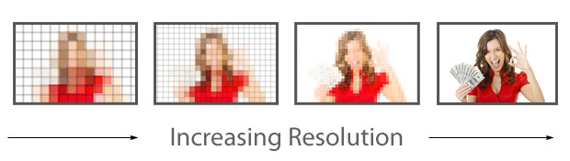

A higher resolution means more pixels are used, and the image is displayed more precisely

# http://tech.firstpost.com/wp-content/uploads/2015/06/Nokia-3310.jpgBitmapped Graphics

Each pixel is represented in binary. In its simplest form, it can be only 1 bit, meaning only black or white. It PNG format, each pixel is represented by 8 hexadecimal bits (32 bits) – each two hex digits representing the red, green, blue and alpha channels – this allows for 232 possible colour combinations.

# Vector Graphics

Vector graphics are defined by paths and co-ordinates. While the can’t store as much detail is bitmap graphics, they can be scaled infinitely without losing quality.

Prep – Digital Cameras

Shutter opens

↓

Light focuses onto a sensor – either a *charge coupled device* or *complementary metal oxide semiconductor*

↓

The sensor, made of millions of transistors, stores the data for each pixel

↓

The sensor converts the light energy into electrons, and the amount of charge for each pixel is recorded – greater intensity = greater charge

↓

The camera uses either 3 different sensors or filters to record colour – for red, green and blue

↓

The data is stored in a compressed format (e.g. TIFF, JPG, PNG) and stored on a storage device, like an SD card

↓

RAW files can also be generated – these are uncompressed, containing all the raw data from the original photograph

↓

The photo can then be transferred to other devices, and/or decoded and changed using specialised software, such as Adobe Photoshop